Preparation and submission of the MSc Thesis for the Master in Photonics and for the Master Europhotonics. Your title goes here
Name of student appears here
Include your affiliation, such as Grup de Recerca en Òptica, Departament d’Òptica, Universitat Politècnica Autònoma de Barcelona, Campus Oest 1, Barcelona 08028, Spain

E-mail: student@upb.edu

Abstract. Use the Abstract section to concisely summarize the contents of your paper. Ideally it will consist of a single paragraph and will include the most relevant information about the context, motivation, development and results of your thesis work. Try not to include references and use a wording that is not automatically reproduced in other parts of the text, such as in the introduction or the conclusions sections.

Keywords: Select four or five keywords that best relate to your thesis work.

1. Introduction: general guidelines
The Master’s Thesis must be written in English and in accordance to the following guidelines. The document has to resemble a research paper, following the format guidelines used by the Institute of Physics (IOP) Publishing in its journals. Full details can be found at the IOP website (http://authors.iop.org/atom/usermgmt.nsf/AuthorServices).
All theses presented the same academic year will be put together and published as a single document. To facilitate your job, you can use this manuscript as a template, editing its contents and filling it out with your information. Take your time to prepare the paper: a professional, research-grade finish would be positively valued by your master thesis committee. In particular, do use a spell-checker. Although the quality of your English will not be an integral part of the grading, careless mistakes will cause a bad impression.
The document must not exceed ten written pages and must be supplied either as a Microsoft Word file or as a LaTeX file. LaTeX class files that may help you format your paper are directly available from the IOP website, at the address specified above. Please, also include an Adobe Acrobat pdf file for sending to the evaluation committee and for archival purposes (see below).
Incidentally, if you do not own a copy of Microsoft Word, you can use the OpenOffice Writer program instead (http://www.openoffice.org). This is a multiplatform, multilingual and freeware office suite that can interoperate with Microsoft Office. Specifically, this template can be imported into and edited with OpenOffice with no problems.
A volume compiling all theses presented during the same year will eventually be made available through the master’s homepage (http://photonicsbcn.eu). Uniformity in style is therefore important and theses written in other formats cannot be accepted.
Since the thesis compilation will be published as an Adobe Acrobat pdf file, make sure that your document prints out nicely into that format. Some tips regarding conversion between word and pdf formats are given below.
Finally, in contrast to IOP rules, both American and British spellings are acceptable here.

2. The title, author name and abstract

2.1. The title
The first letter of the title should be capitalized with the rest in lower case. The title should be formatted using 17 point Times Bold, flush left and unjustified, and you should leave 28 mm of space above, and 10 mm below, the title.

2.2. Running heads
The title of your work should be used as the running head of your article. If it is too long, please use a shorter version, as in we do in this document.

2.3. Addresses and footnotes
The address of the author’ affiliation follows the name of the author. Place here the information about the laboratory, unit, centre and university where you carried out your MSc thesis work.

2.4. E-mail addresses
These may be added after the authors’ addresses.

2.5. The abstract
The abstract follows the addresses and should give readers concise information about the content of the article and indicate the main results obtained and conclusions drawn. It should be self-contained with no reference to figures, tables, equations or bibliographic references and should not normally exceed 200 words. The abstract should normally be restricted to a single paragraph.

3. Formatting the text
The text may be divided into sections, subsections and, where necessary, sub-subsections.

3.1. Fonts
Please format the text of your article using a ‘Times’ font at a size of 11 points. Note that you may need to use ‘Times Roman’ or ‘Times New Roman’ depending on the fonts installed on your computer.

3.2. Formatting sections, subsections and sub-subsections
The first section is normally an introduction, which should state clearly the object of the work, its scope and the main advances reported, with brief references to relevant results by other workers. Please, notice that most of the potential readers of your paper, including the members of your master’s thesis evaluation committee, may not be familiar with your particular research topic. That is in contrast to the readership of a regular scientific paper, so make your introduction longer and more detailed than what is customary in that context.

3.2.1. Style, spacing and numbering.
Table 1 shows our preferred format for section headings.

Table 1. Formatting sections, subsections and sub-subsections.

 | Numbering | Font | Spacing
Section | 1., 2., 3., etc | 11 point Times bold | 1 line space before a section  No additional space after a  section heading
Subsection | 2.1., 2.2., 2.3., etc | 11 point Times Italic | 1 line space before a  subsection  No space after a subsubsection  heading
Sub-subsection | 2.3.1., 2.3.2., etc | 11 point Times Italic | Subsubsections should end  with a full stop (period) and  run into the text of the  paragraph

3.3. Acknowledgments
If you wish to acknowledge the assistance, direction and encouragement from your thesis advisor or from other persons, as well as special work done by technical staff or financial support from organizations you should do so in an unnumbered ‘Acknowledgments’ section immediately following the last numbered section of the article. See an example at the end of this document.

3.4. Appendices
Technical detail that it is necessary to include, but that interrupts the flow of the article, may be included as an appendix. Appendices should be included at the end of the main text of the article, after the acknowledgments but before the reference list. If there are two or more appendices they should be called Appendix A, Appendix B, etc. Numbered equations will be in the form (A.1), (A.2), etc, figures will appear as figure A1, figure B1, etc and tables as table A1, table B1, etc.

4. Figures
Figures should be embedded in the text as in the example (figure 1) below. Each figure should have a brief caption describing it and, if necessary, a key to interpret the various lines and symbols on the figure. Aim to keep the lettering on figures to a minimum and include as much detail as necessary in the captions.

4.1. Figure captions/numbering
Captions should be placed below (or next to) the figure and should finish with a full stop (period). Figures should be numbered sequentially—‘Figure 1’, ‘Figure 2’, and should be cited in the text as ‘figure 1’, ‘figure 2’.

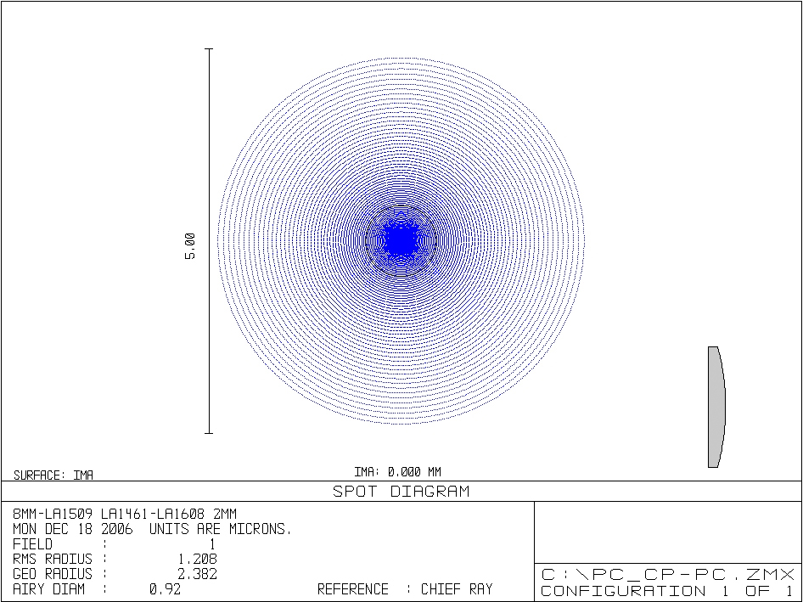 | 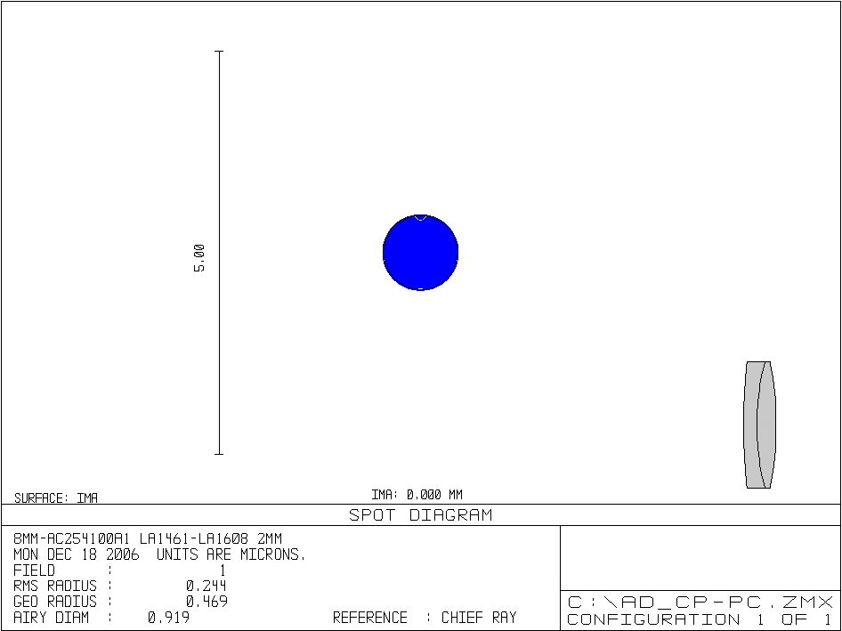
(a) | (b)
Figure 1. Spot diagrams when the following shape of lens LC is used: (a) plano-convex, (b) achromatic doublet.

4.2. Positioning figures
Individual figures should normally be centred. It is also more convenient for referees of your article if figures are placed as close as possible, and ideally after, the point where they are first mentioned in the text. If necessary, figures and their captions can be grouped together at the end of the article.

4.3. Figures in parts
If a figure has parts these should be clearly labelled as (a), (b), (c) etc on the figure. Parts should not have separate captions, but the caption should describe the different parts.

5. Tables

5.1. Positioning tables
Tables should be centred unless they occupy the full width of the page.

5.2. Table captions/numbering
Captions should be placed at the top of the table, see Table 1, and should finish with a full stop (period). Narrow captions should be centred, longer captions simply typed as a paragraph. Tables should be numbered sequentially—‘Table 1’, ‘Table 2’, and should be cited in the text as ‘table 1’, ‘table 2’.

5.3. Rules in tables
Tables should have only horizontal rules and no vertical ones. Generally, only three rules should be used: one at the top of the table, one at the bottom, and one to separate the entries from the column headings.

6. Equations and mathematics
Mathematics should be prepared using Word’s built-in ‘Equation Editor’ or the full MathType product. Full details for formatting equations can be found on the IOP Word Guidelines document.

Avoid ‘Insert Symbol’
Please avoid using Word’s ‘Insert Symbol’ command. Symbols inserted in this way may not appear in the PostScript and PDF file of your article—they often ‘drop out’. Instead, for example, to type Greek characters, type the corresponding Latin character (e.g., ‘a’ for α) and manually change the font to Symbol using Format → Font and then select ‘Symbol’ font.

6.1. Equation numbering
Equations should be numbered sequentially throughout the text (i.e., (1), (2), (3), ...) or numbered by section (i.e., (1.1), (1.2), (2.1), ...) depending on your preference. In articles with several appendices equation numbering by section is useful in the appendices even when sequential numbering has been used throughout the main body of the text: for example, A.1, A.2,…,B.1, B.2,…. When referring to an equation in the text:
- always put the equation number in brackets—e.g. ‘as in (2)’ or ‘as in (2.1)’;

it is not normally necessary to include the word ‘equation’ before the number.

7. References

7.1. General
Citation rules for IOP journals are somewhat cumbersome and vary depending on the kind of reference that you are pointing to: scientific articles, books, electronic documents, etc. We provide you with several examples below that you can edit and adapt to your own needs. In case you require citing a more sophisticated resource please, refer to the IOP Guidelines document.

7.2. What should a reference contain?
A complete reference should provide the reader with enough information to locate the article concerned, whether published in print or electronic form, and should, depending on the type of reference, consist of:
- family name(s) and initials of all authors;
- titles of journal articles (optional);
- year of publication;
- title of journal, book or other publication;
- volume number;
- editor(s), if any;
- town of publication and publisher for books;

page numbers.

Acknowledgments
Example: This research was funded by the Spanish Ministry of Education and Science through grant XXXX. I am indebted to my advisor, Prof. XXXX for his help and encouragement throughout the course of this work.

References
[1] Dufresne E R and Grier D G 1998 Optical tweezer arrays and optical substrates created with diffractive optical elements Rev. Sci. Instrum. 69 1974-1977
[2] Dufresne E R, Spalding G C, Dearing M T, Sheets S A and Grier D G 2001 Computer generated holographic optical tweezer arrays Rev. Sci. Instrum. 72 1810-1816
[3] Hayasaki Y, Itoh M, Yatagai T and Nishida N 1999 Nonmechanical optical manipulation of microparticle using spatial light modulator Opt. Rev. 6 24-27
[4] Reicherter M, Haist T, Wagemann E and Tiziani H 1999 Optical particle trapping with computer-generated holograms written on a liquid-crystal display Opt. Lett. 24 608-610
[5] Grier D G 2003 A revolution in optical manipulation Nature 424 810-816
[6] Dholakia K and Reece P 2006 Optical micromanipulation takes hold Nanotoday 1 18-27
[7] Creely C M, Volpe G, Singh G P, Soler M and Petrov D V 2005 Raman imaging of floating cells Opt. Express 13 6105-6110
[8] Block S M 1998 Constructing optical tweezers in Cell Biology: A Laboratory Manual, ed D Spector, R Goldman and L Leinward (Cold Spring Harbor, NY, Cold Spring Harbor Press)
[9] http://www.microscopyu.com/articles/optics/cfintro.html
[10] Goodman J W 1996 Introduction to Fourier Optics (New York: McGraw-Hill)
[11] Efron U 1995 Spatial light modulator technology: materials, devices and applications (New York: Marcel Dekker)
[12] Smith W J 2000 Modern optical engineering (New York: McGraw-Hill)

